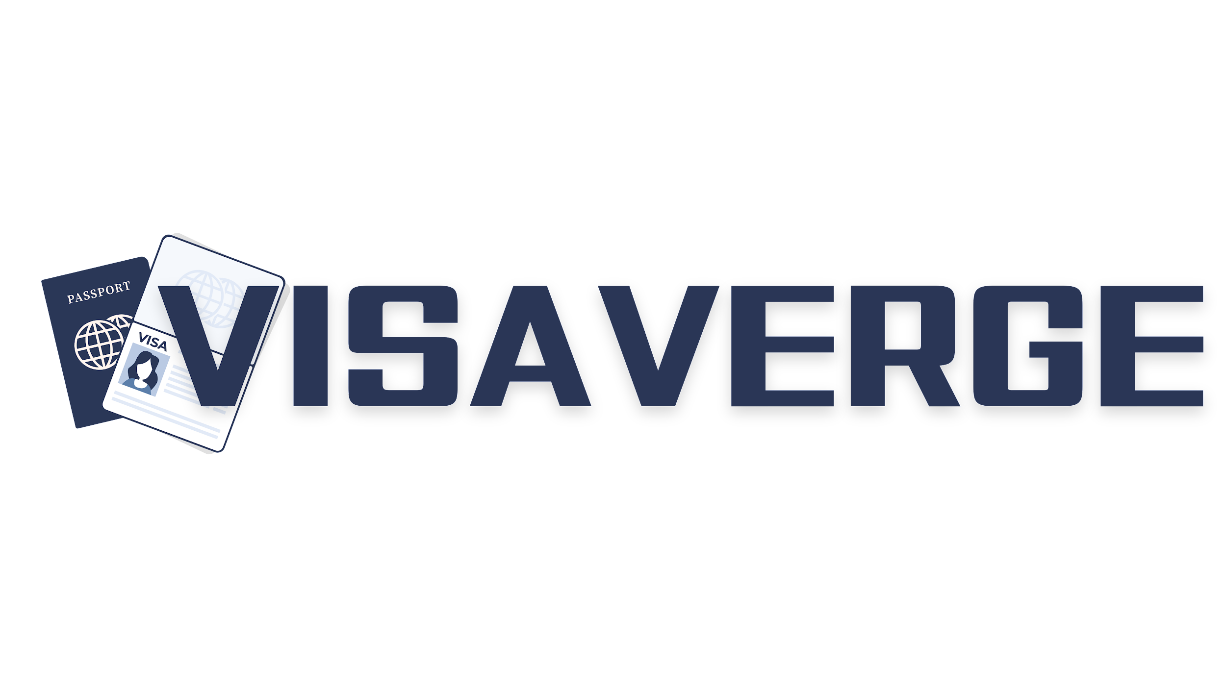

## **Sample Cover Letter for Business Schengen Visa**

**Subject: Schengen Visa Application for Business Trip**

Bangalore, India  
March 24, 2023

Embassy of Germany  
45 MG Road  
Bangalore, India

Dear Sir/Madam,

I am Rajesh Kumar, writing on behalf of my employer, Future Enterprises Pvt. Ltd., based in Bangalore, India, to request a Business Schengen Visa for myself. My passport number is A98765432.

The purpose of my visit is to attend business meetings and workshops with our business partner, Green Tech Innovations, located in Frankfurt, Germany, scheduled from April 15, 2023, to April 22, 2023. These meetings are crucial for the upcoming joint venture that we are due to sign, which will significantly benefit both companies involved.

During my stay, I will be accommodated at Hilton City Hotel in Frankfurt, and all my expenses will be borne by Future Enterprises Pvt. Ltd. as per our corporate travel policy.

Enclosed are all pertinent documents, including my itinerary, invitation letter from Green Tech Innovations, company support letter, proof of financial means, hotel reservation, and round-trip flight bookings.

I kindly request a prompt processing of my visa application. Please contact me should you require more information.

Sincerely,

Rajesh Kumar  
[Full address in India]  
[Contact Information]