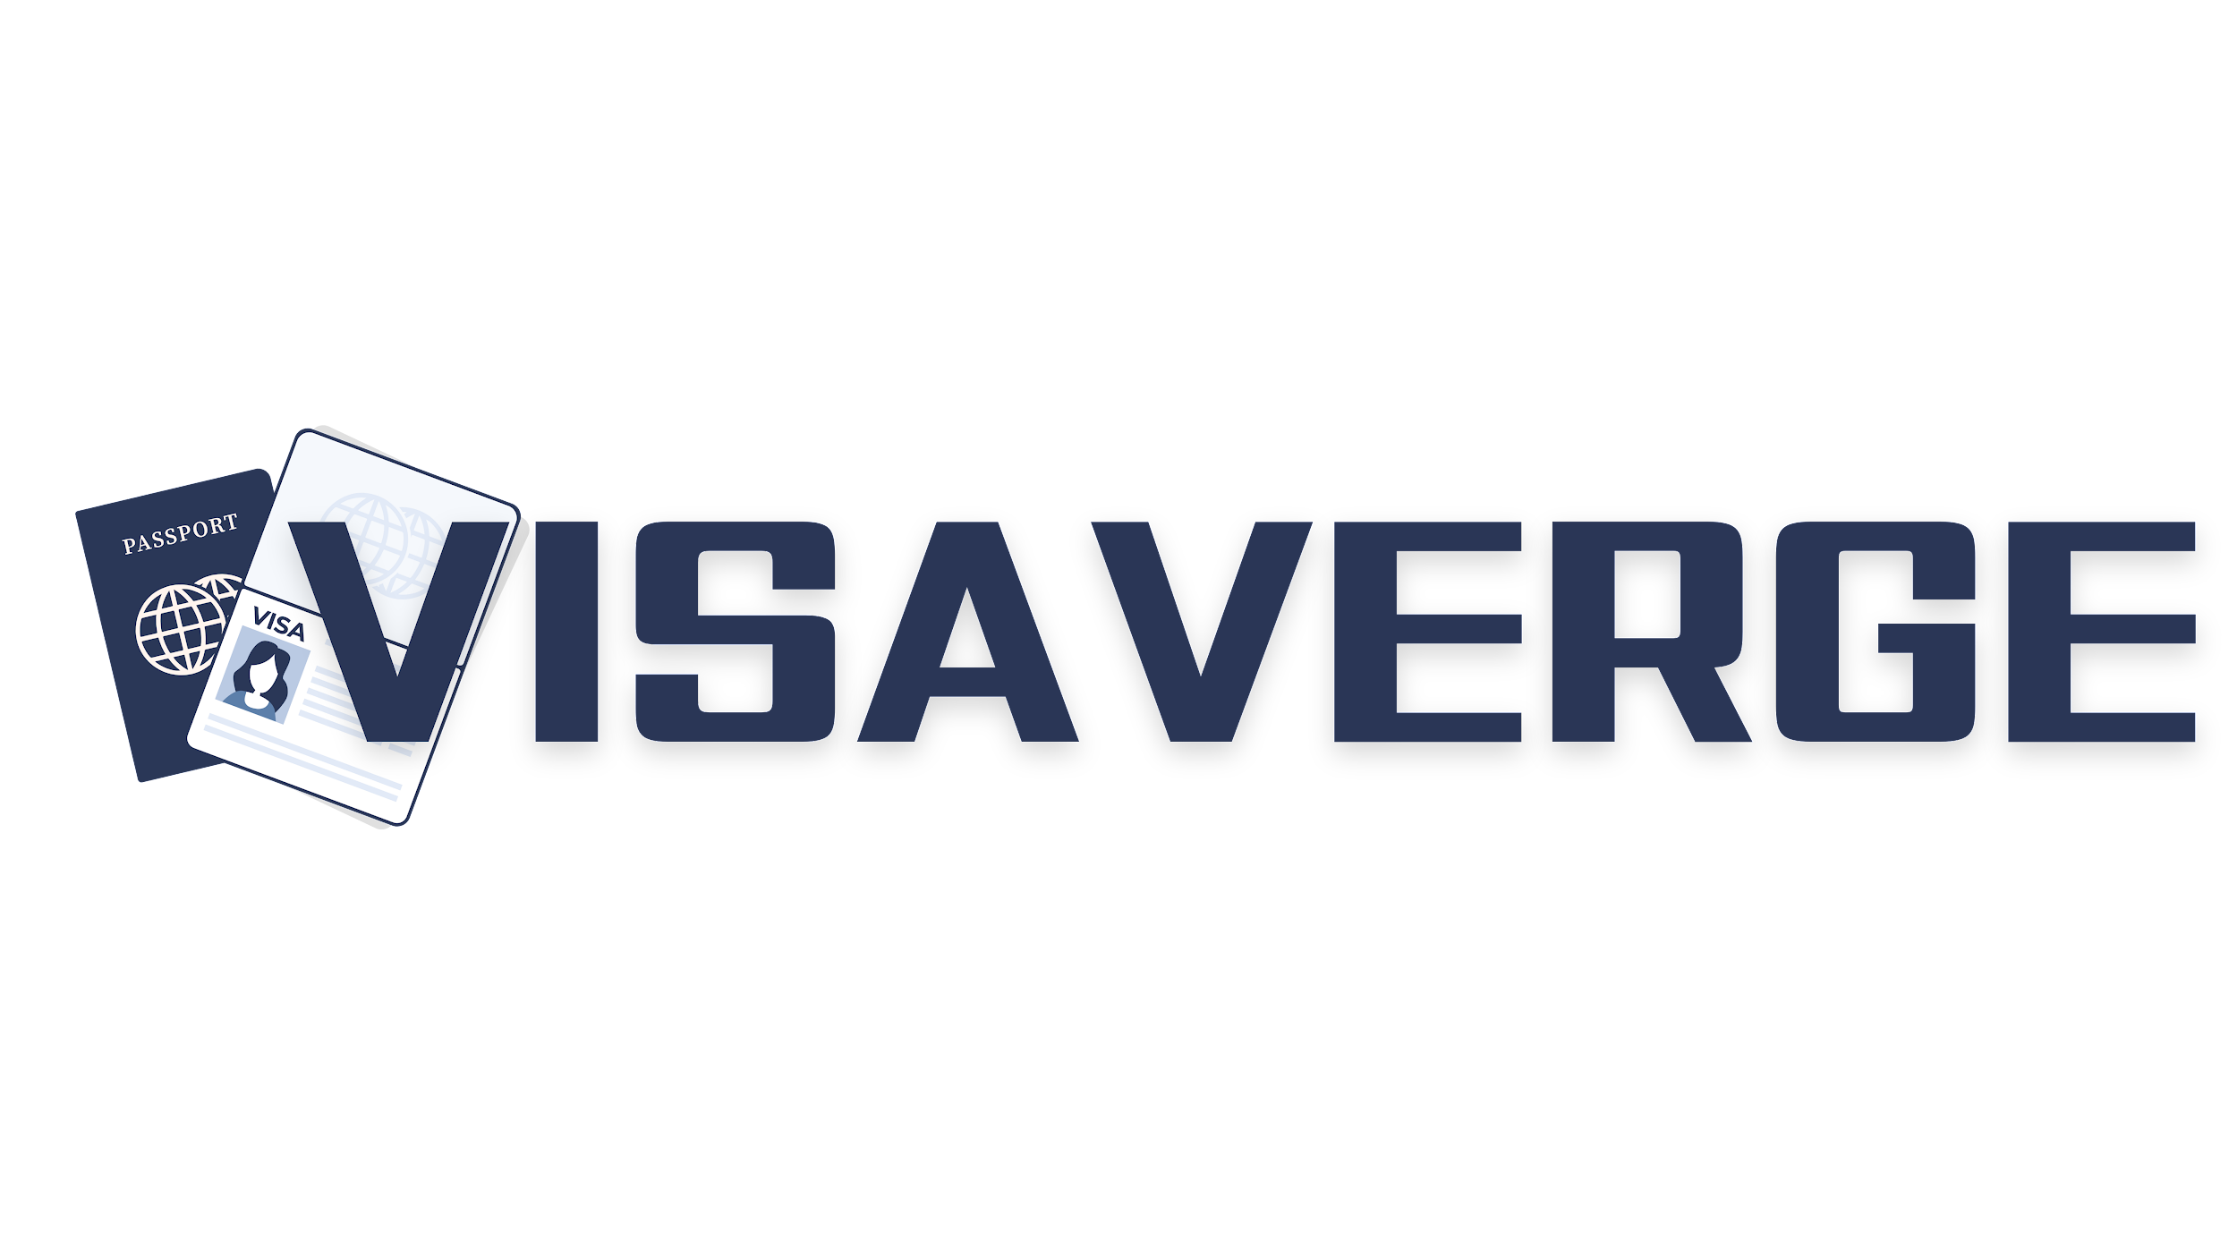

Sample Letter 2: Appeal for Business Visa Refusal

Jane Smith
456 Oak Avenue
Second City, Canada L2P 9M8
Phone: +1-654-321-9876
Email: janesmith@email.com

Date: March 15, 2023
Consulate General of [Country]
[Consulate Address]
[City, Postal Code]
Country
Dear Visa Officer,
I am writing to appeal the decision made regarding my business visa application, reference number CA987654321, dated March 1, 2023. My planned trip to [Country] was intended for important face-to-face meetings with our business partners at [Company Name, Address], scheduled from April 5th to April 12th, 2023.
The refusal notice highlighted concerns regarding the documentation provided for the purpose of my visit. I understand the importance of ensuring proper documentation and would like to address the concerns through additional substantiation attached herewith.
To clarify the intent and support my application, attached are the following:
1. A detailed invitation letter from [Company Name in Country] outlining the meeting agenda.
2. A letter from my employer [Your Company’s Name] affirming my designation as [Your Position] and the necessity of these negotiations.
3. Complete itinerary of my business engagements during the stay in [Country].
4. Proof of previous partnerships and business conducted between my company and the company in [Country], showcasing the long-standing relationship.
I am committed to adhering to the laws and regulations of [Country] during my stay and have a substantial connection to my home country, Canada, which includes my family, my job, and my property, all compelling me to return.
I kindly request you re-evaluate my application in light of the additional documents provided. Please consider my appeal and permit me to proceed with my scheduled business commitments in [Country].
Thank you for your attention to this matter. I look forward to your positive response and am happy to provide any further information needed.
Warm regards,
Jane Smith

